**How to Scale Sales at Your Startup**

The journey from one sale to one hundred starts with you.

Photo by [Arlington Research](https://unsplash.com/@arlington_research?utm_source=unsplash&utm_medium=referral&utm_content=creditCopyText) on [Unsplash](https://unsplash.com/s/photos/call-centre?utm_source=unsplash&utm_medium=referral&utm_content=creditCopyText)

Y

ou’ve built a product or service that you plan to sell into companies. While the development team was building it, you went out and started to build relationships. After months of effort, you’ve landed a few pilots that represent a foot in the door.

You lean back and think, ‘This product is amazing. It’s time to scale sales as quickly as possible’. If this is where you are right now, great — I’m going to share with you exactly how to do it.

But if you’ve already tried to scale sales and it hasn’t worked, that’s fine too. We’ll go through the process step-by-step and see where you might have tripped up.

**The Scaling Mindset**

If you want to scale sales, you have to understand what you’re selling. Consulting or early-stage fundraising are often the only sales-like experience founders have, and both boil down to selling yourself.

If you want to scale your sales, you need to realise that you aren’t selling yourself, you are selling your ***product outcomes***. You aren’t actually needed to sell a product outcome, and it’s critical to understand that. Rather, you’re building a machine you can step out of later.

**The ‘Standard’ Sales Org Structure**

Before we begin, it’s worth looking at where you want to end up. At scale, sales organisations tend to look similar, with four categories of roles:

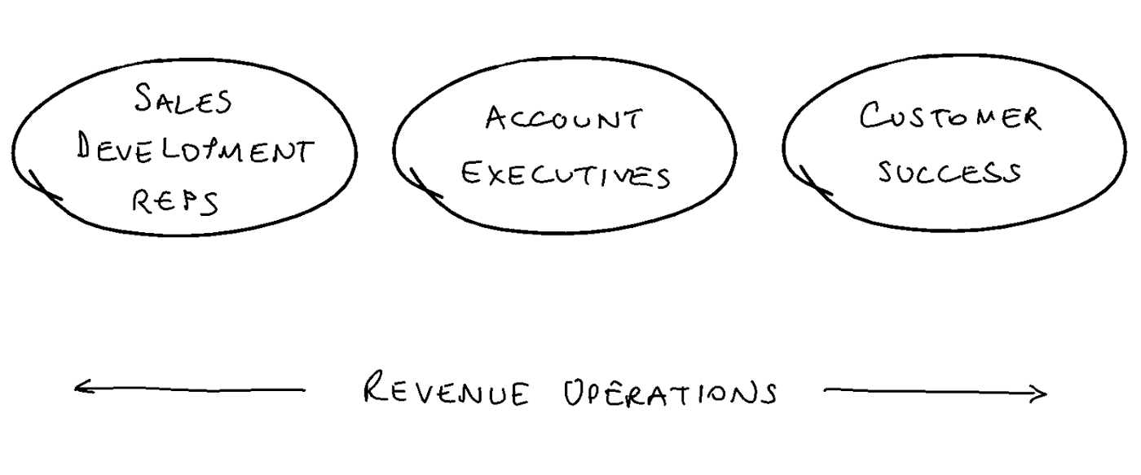

**1) Sales Development Reps (SDRs)**

Sales development reps provide account executives with a quota of relevant leads, known as ‘sales qualified leads’ (SQLs). This starts with a clear understanding of your ideal customer profile (ICP), which helps narrow down the types of people or businesses that could get the most value from your offering. You’ll continue to refine your ICP as you learn more about customers, evolve your product, and grow into new markets.

Armed with a clear ICP, SDRs can reach out to new prospects by asking them, ‘Are we a fit?’ (known as the ‘AWAF question’). They can also qualify inbound prospects from marketing campaigns and partnerships and if they *are* a fit, congratulations — you’ve found an SQL. If not, it’s on to the next prospect.

Many teams use software to help them do this at scale. You know those emails and LinkedIn reach-outs you receive? They are most likely automated using software—an approach that many teams experiment with. Sales is a numbers game and a high proportion of outreach will be unsuccessful. After all, you have to reach the right person at the right time with the right message, and this isn’t easy.

Effective sales development is fundamental to scaling. If you’re limited to your own network, or if you believe cold outreach is scarily impossible, then you’re going to find it hard to massively grow your customer base.

**2) Account Executives (AE)**

An account executive’s objective is to work with leads and help them make the right purchase decision, hopefully resulting in a sale.

Prospects rarely go from ‘interested’ to ‘signed’ in one step, so AEs work with the concept of a sales pipeline — a research-based series of discrete steps along the way to the sale.

Rather than push all leads straight to the sale, the goal is to move them one step along the pipeline.

Many founders approach sales in the same way they pitched investors. However, there’s usually a big difference — unlike VC funds, companies have a much wider variety of stakeholders. It’s common for multiple departments to be involved, such as IT, HR, and finance.

This makes pipelines complex and lots of materials will be required. For example, you might have multiple sales decks, depending on the stakeholder you’re speaking with. At each stage of the pipeline, you’ll uncover best practices that help maximise your sales team’s effectiveness. These tactics can form a ‘playbook’ to help AEs improve their performance and quickly onboard new recruits.

Frameworks like [MEDDICC](https://www.forcemanagement.com/meddicc) can help you qualify the strength of complex sales by breaking them down:

* **Metrics** — quantifiable measurements and proof of business benefits
* **Economic buyer** — the individual who is required for the final ‘yes’
* **Decision criteria** — solution requirements that will be evaluated for the decision
* **Decision process** — the process to evaluate, select, and purchase a solution
* **Identified pain** — the customer pain that is a catalyst for solving the problem
* **Champion** — the person with the power and influence
* **Competition** — competitive strengths, weaknesses, and differentiators

You might have the impression that an effective AE needs to be as ruthless as *The Wolf of Wall Street*, but modern sales is far less pushy. Rather than hustling clients to close contracts they don’t really want, a good AE builds a trusted relationship by helping to uncover and clarify a ***prospect’s needs***. If the right needs are present, the [product can be prescribed like a medicine, rather than sold like unwanted double-glazing](https://medium.dave-bailey.com/a-founders-guide-to-sales-meetings-ddb9aff7d3de).

**3) Customer Success Manager (CSM)**

Once the contract is signed, the customer is introduced to their Customer Success Manager, who will help them set up the product and get value from it. Onboarding a product into a company is no easy feat, especially if a large number of people are involved. CSMs assume the project manager role.

However, just because a company *can* use your valuable solution, it doesn’t mean they *will*. Have you ever rediscovered something useful you bought years ago and thought, ‘Gosh, that would have been useful last week—how did I forget about it?’ Engagement campaigns are needed to prevent customers forgetting about you, and they’re particularly important for non-habitual products that aren’t used daily.

CSMs can retain customers by ensuring they are getting the most value from the product and growing new relationships within the company (eventually, your champion may leave for another company).

However, if you’re using your CSMs just for retention, you might be leaving money on the table. CSMs can also cross- and up-sell existing customers, which leads to the holy grail of growth: **positive churn**. This sounds strange at first — doesn’t churn measure how you *lose* customers? If the amount spent by existing customers increases faster than you lose accounts, your sales might grow even without new customers.

**4) Revenue Operations**

A modern sales department may use dozens of software tools. To give you an idea, there are [hundreds of solutions for such areas](https://www.saleshacker.com/sales-tools/) as:

* Account-based Sales and Marketing
* Analytics
* Communication/Conferencing
* Content Sharing and Management
* Contract Lifecycle Management
* Customer Relationship Management (CRM) Systems
* Email Management
* Lead Generation, Productivity, Prospecting
* Performance Management
* Sales Engagement
* Sales and Market Intelligence

Each tool needs to be set up and configured. Teammates need to be trained to use the tools. And metrics should be collected to provide visibility over performance and how to use the tools more effectively. Who’s responsible for this?

Revenue operations oversee effective tooling and reporting in the sales organisation, and they are critical if you want to sell without unleashing chaos.

**How to Grow a Sales Organisation from Scratch**

After making (and seeing) a lot of mistakes when building out a sales team, I’ve noticed that many of them come from logical reasoning that turns out to be wrong. To help keep you on the right track, here’s some guidance on how to scale effectively.

**1) Charge enough to cover your sales team.**

If you’re [not charging enough for your product or service](https://medium.dave-bailey.com/how-to-charge-what-your-product-is-worth-b51c17d832d8), you may not be able to afford a sales team. In *Zero to One*, Peter Thiel describes a ‘dead zone’ in which the software is too cheap to be sold by salespeople and too expensive to be sold online.

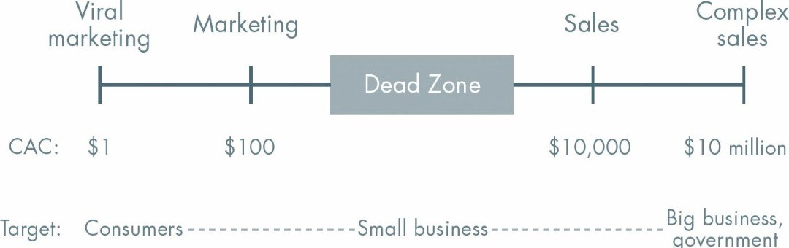

A rule of thumb is that your Life-Time Value (LTV) should be three to five times greater than your cost of acquiring a customer (CAC) — and that includes sales. If the ratio is too low, you’re probably charging too little, and if it’s too high, there is an opportunity to grow more aggressively.

**2) The founder should make the first 10 sales**

If you hate sales, you may be tempted to hire a salesperson from the outset. However, I have *never* seen this work out. In the beginning, sales are always disappointing. There are just too many moving parts: the product itself, how to position it, who your ideal customer is, etc. If you try to hire someone, you’ll inevitably ask yourself, ‘Did I just hire the wrong person?’ And once there’s doubt, they aren’t going to succeed.

I used to hate sales too. But I love it now. What made the difference? As I [explain here](https://medium.dave-bailey.com/a-founders-guide-to-sales-meetings-ddb9aff7d3de), dragging myself into a sales training course was all it took for me to get excited about it.

**3) Start by hiring SDRs**

Let’s assume you’ve made a bunch of sales and you’re ready to scale. It sounds like a logical idea to hire a senior leader first and allow them to build their team. Better still, you’d get your time back — after all, you have other priorities, right?

Sadly, I haven’t seen this work well either. Senior sales managers don’t want to be micromanaged, so you can end up losing a lot of what you’ve already found works. Plus, senior sales managers might not be used to actually selling and the learning curve can be steep for them. Again, once doubt creeps in, they’re toast.

Instead, you need to suck it up and hire junior salespeople first, who can shadow you for six months. You want to uncover and document repeatable sales processes that your team can use without you. Once you have a well-oiled sales machine, you can hire someone senior to take it from there.

**4) Hire two or more at a time**

It might sound logical to hire one person first, to test the waters. However, what exactly are you testing? If they don’t sell anything, have you learned your product can’t be sold? Or have you learned that you don’t have an effective salesperson?

Hiring more than one salesperson allows for comparison. For example, you might hire three and only keep the one who performs best. Having different people on the team also allows you to see how different styles and tactics perform, and that’s how you get better.

Finally, sales is one of the few areas in a startup that [benefits from extrinsic motivators](https://medium.dave-bailey.com/how-to-get-your-team-to-want-to-work-longer-hours-e688a2933620) like commission and bonuses. Competition is an extrinsic motivator too — and just having a peer to compete with can be an effective stimulus.

**5) Hire a Revenue Ops sooner rather than later**

Revenue Ops may sound like a ‘big company’ role since it’s likely to be so specialised. However, the most common thing I hear from founders about rev ops is, ‘I wish I’d hired one sooner!’ Having the right tooling and reporting is a game-changer for scaling your sales. Even a team of four or five people can benefit massively from the right tech and insights.

**6) Motivate, motivate, motivate**

Sales is emotionally exhausting because you hear a lot of ‘nos’. Sales leaders need to recognise this and maintain a high-energy level in the team. It’s not uncommon for sales teams to play dance music and give each other high-fives to boost morale. But there’s one thing that builds morale better than anything . . . and that’s sales.

Giving your team opportunities to learn and develop is critical. That’s why great sales leaders are great coaches. If you’re coaching a sales rep, get them to bring up specific situations from the previous week and work through them together. Some companies record sales calls specifically for this reason. Asking questions is an effective way of coming up with alternative actions they can put into practice the following week. Little improvements make a big difference. Role-playing in front of the team is also very effective in increasing the rate of learning.

**Scaling Sales is Sophisticated**

We’ve now taken a high-level overview of how sales organisations work at a large company. However, as with everything in life, the devil is in the detail. Each one of the roles we’ve discussed will go through a learning curve related to your product, and this takes time.

Be prepared to invest in this machine. It could take a year or two to set up and scale in the way you want to — but the results can set your company up for life.